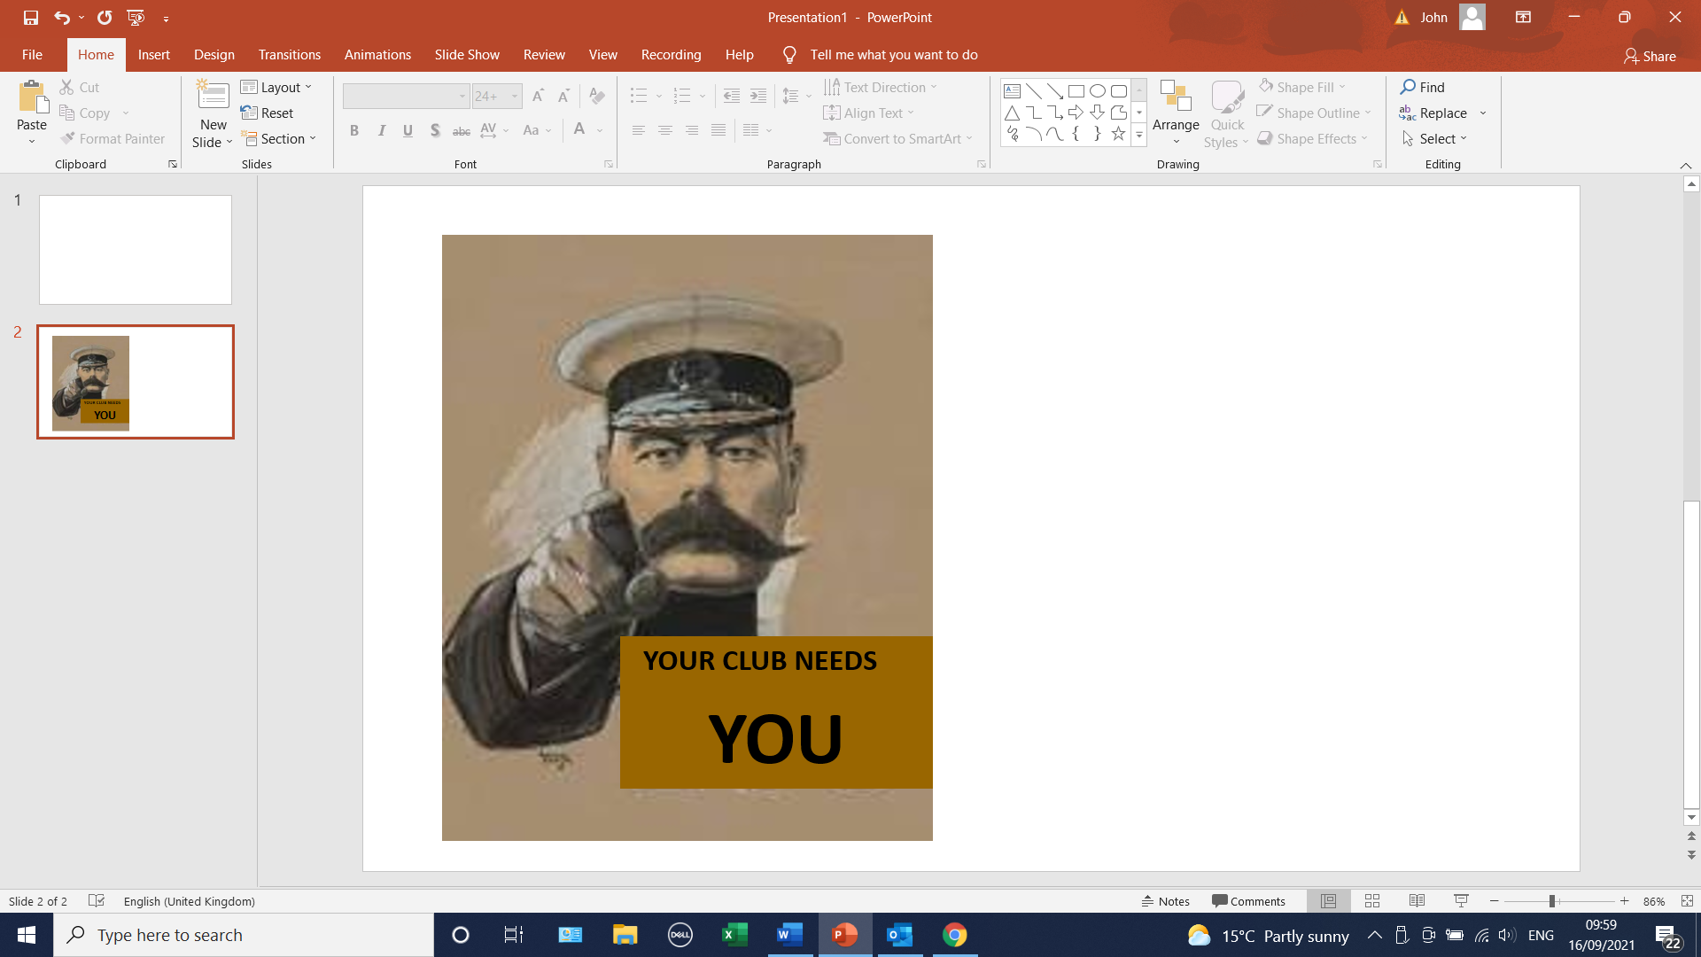

The Club is looking for additional volunteers to run the bar on a Friday evening.

If we are unable to recruit extra help we shall have to reduce opening to every other week rather than weekly.

**Contact John Short for further information or with offers of help by 24th Sept.**

[jrshort@btinternet.com](mailto:jrshort@btinternet.com)

mob. no. 07768821629